Transitional Services of Iowa

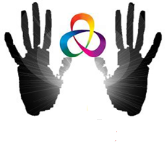
Transitional Services of Iowa
Contact
Information:

Main Office
1221 Pierce Street
Sioux City, IA 51105
Phone: 712.255.0204

300 West Broadway Suite 29
Council Bluffs, IA 51503
Phone: 712.323.1660

1207 Sunnyside Ln Suite D
Atlantic, IA 50022
Phone: 712.243.7089

216 N. Main St
Charles City, IA 50616
Phone: 641.228.2050

http://www.transitionalservicesofiowa.org
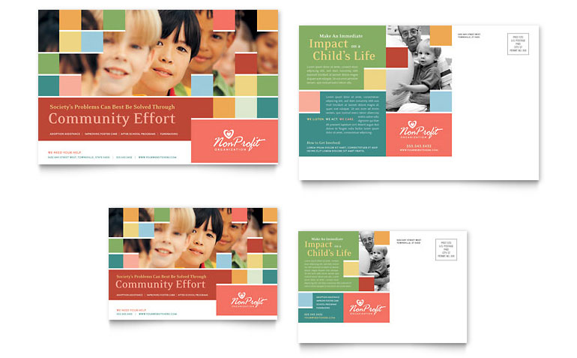

Services we offer:

BHIS-Behavior Health Intervention Services

Individual, Family and Group Therapy

PCIT- Parent Child Interaction Therapy

Substance Abuse Treatment

Family Team Meetings

Supervised Visits

Child Mental Health Waiver

Transitional Services of Iowa

Our Mission
Transitional Services of Iowa, Inc. is committed to providing distinctive, quality, and unparalleled client services as we strive to gain the respect and trust of our clients and community partners while preserving, restoring and strengthening families by thorough and effective assessment and successful treatment.

Building Skills for a Lifetime
Behavioral Health Intervention Services (BHIS) are in-home, skill based services:

- Conflict Resolution

- Problem Solving

- Social Skills & Relationship building/maintaining

- Communication Skills & Language Processing

- Executive Function (planning, attention, verbal reasoning, inhibition, mental flexibility, and multi-tasking)

- Emotional Regulation

Children and adults will…
- Develop and apply pro-social skills
- Develop and enhance interpersonal communication and interaction skills
- Develop and apply self- control skills
- Reduce anger and aggression, and manage emotions appropriately
- Develop and apply healthy, age- appropriate decision making skills
- Enhance self-esteem and self-efficacy

Learn to utilize new techniques for...

Losing one’s temper

Arguing with others
- Actively defying requests
- Refusing to follow rules
- Deliberately annoying other people
- Testing limits and pushing boundaries
- Being rejected by peers
- Low self-esteem
- Severe mood changes
- Distractibility (ADD, ADHD)
- Difficulty communicating
- Poor school performance
- Social and emotional anxieties

Mental Health Therapy
Services provide a strength based approach to alleviating stress and strengthening families. TSI offers therapeutic services to children, adolescents, and adults for individual, family and group sessions.

Parent Child Interaction Therapy

TSI also offers specialized therapeutic services called Parent-Child Interactive Therapy (PCIT).

PCIT is a training intervention that teaches caregivers specific behavior management techniques as they play with their child.

PCIT focuses on improving the caregiver-child relationship and increasing children’s positive behavior

Child Mental Health Waiver
Children who have serious mental disturbances and are at imminent risk of out-of-home placement or are likely to be at risk can sign up for the Child Mental Health Waiver through DHS. (Many times there is a waiting list, therefore, sign up immediately if the need is identified). CMH services provides: mentoring, coaching, socialization, personal hygiene skills, skill development, therapy, crisis intervention and building relationships.
Family Team Meetings
Referrals from the Department of Human Services and any other concerned party. This is a structured meeting to identify strengths, needs and a plan related to children who are placed out of the home, are at risk of being removed from the home or have a mental health diagnosis in which planning needs to occur.

Supervised Visitation
Referrals from attorney or parents who need to have court ordered supervised visits. Visits are supervised and are at the cost of the parent receiving the visitation.

Fitness and Wellness
A gym located at the Sioux City Office and has trained physical fitness trainers who assist in establishing healthy eating patterns as well as develop a plan for training the body. Fitness classes for adults, youth and children are provided as well as a multitude of athletic programming for healthy living.

Chemical Dependency & Addiction
The Chemical Dependency and Addictions Programs of TSI focus on the identification and treatment of all types of addictions and on the prevention of addiction through education and awareness.

Access To Recovery
The goals of the ATR program are to support client choice and increase the array of faith-based and community based providers. ATR Iowa focuses on serving individuals in recovery from substance abuse. ATR can assist in so many diverse interests to assist a person who is trying to recover or in the early stages of recovery.

Available services with ATR:
- Care Coordination
- Life Skills
- Recovery Calls
- Sober Living Activities
- Supplemental Needs
- Transportation

DUI Assessment & DUI Classes
DUI classes assist with defining a plan of action after an arrest for driving while intoxicated. We provide the court ordered class in order to regain your driver’s license.

We accept the following:
Title XIX
Private Insurance
Sliding Fee Scale

