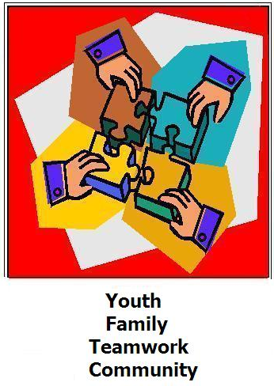
1221 Pierce Street
Sioux City, IA 51105
Phone: 712.255.0204

300 West Broadway Suite 29
Council Bluffs, IA 51503
Phone: 712.323.1660

115 Plymouth St NW
Le Mars, IA 51031
Phone: 712.389.4750

1207 Sunnyside Ln Suite D
Atlantic, IA 50022
Phone: 712.243.7089

http://www.transitionalservicesofiowa.org

TSI
Transitional Services of Iowa, Inc. is committed to providing distinctive, quality, and unparalleled client services as we strive to gain the respect and trust of our clients, and community partners while preserving, restoring, and strengthening families by thorough and effective assessment and successful treatment.

Transitional Services of Iowa
Transitional Services of Iowa
To inquire about services please contact one of the offices listed on the back of this brochure.
TSI
OFFICES

Building Skills For A Lifetime
We know you want your child to be successful in life and so does TSI!
There are skills we learn in our life to help us succeed such as:
- Managing behaviors
- Respecting authority
- Following the rules
- Peer relationships
- Social Skills
- Problem solving
- Communication
- Relationship with parents
Programs Offered by TSI….
The following are BHIS Services that are funded through Title 19:
- Health and Behavioral Intervention (Individual, Group, and Family)
- Crisis Intervention

Behavioral Health Intervention Services

Behavioral Health Intervention Services (BHIS) are skill building interventions that alleviate behaviors and symptoms associated with a mental health disorder such as:
- Losing one’s temper
- Arguing with adults
- Actively defying requests
- Refusing to follow rules
- Deliberately annoying other people
- Blaming others for misbehavior
- Testing limits and pushing boundaries
- Being rejected by peers
- Witnessing drug use or domestic violence
- Has low self- esteem
- Engaging in delinquent behavior
- Has severe mood changes
- Distractibility ( ADD, ADHD)
- Significant change in body weight
- Persistent sadness or irritability
- Has difficulty in relationships
- Has difficulty communicating
- Has poor school performance
- Has anxiety
Children will…
- Develop and apply pro-social skills
- Develop and enhance interpersonal, communication & interaction skills
- Develop & apply self- control skills to reduce anger and aggression, and manage emotions appropriately
- Progress from superficial moral reasoning levels to a more profound mature level of interpersonal and socio- moral reasoning
- Remediate cognitive distortions & errors in thinking
- Develop and apply healthy, age- appropriate decision making skills
- Enhance self-esteem and self-efficacy
To inquire about services please contact one of the offices listed on the back of this brochure.

